Quadruped Robot For Smart Agriculture

Team: Austin Neff, Kevin Nelson, Jordan Raver, Ben Siesser, Sam Spencer, Yang Yang

Team Advisors: Shad Roundy, Kam Leang

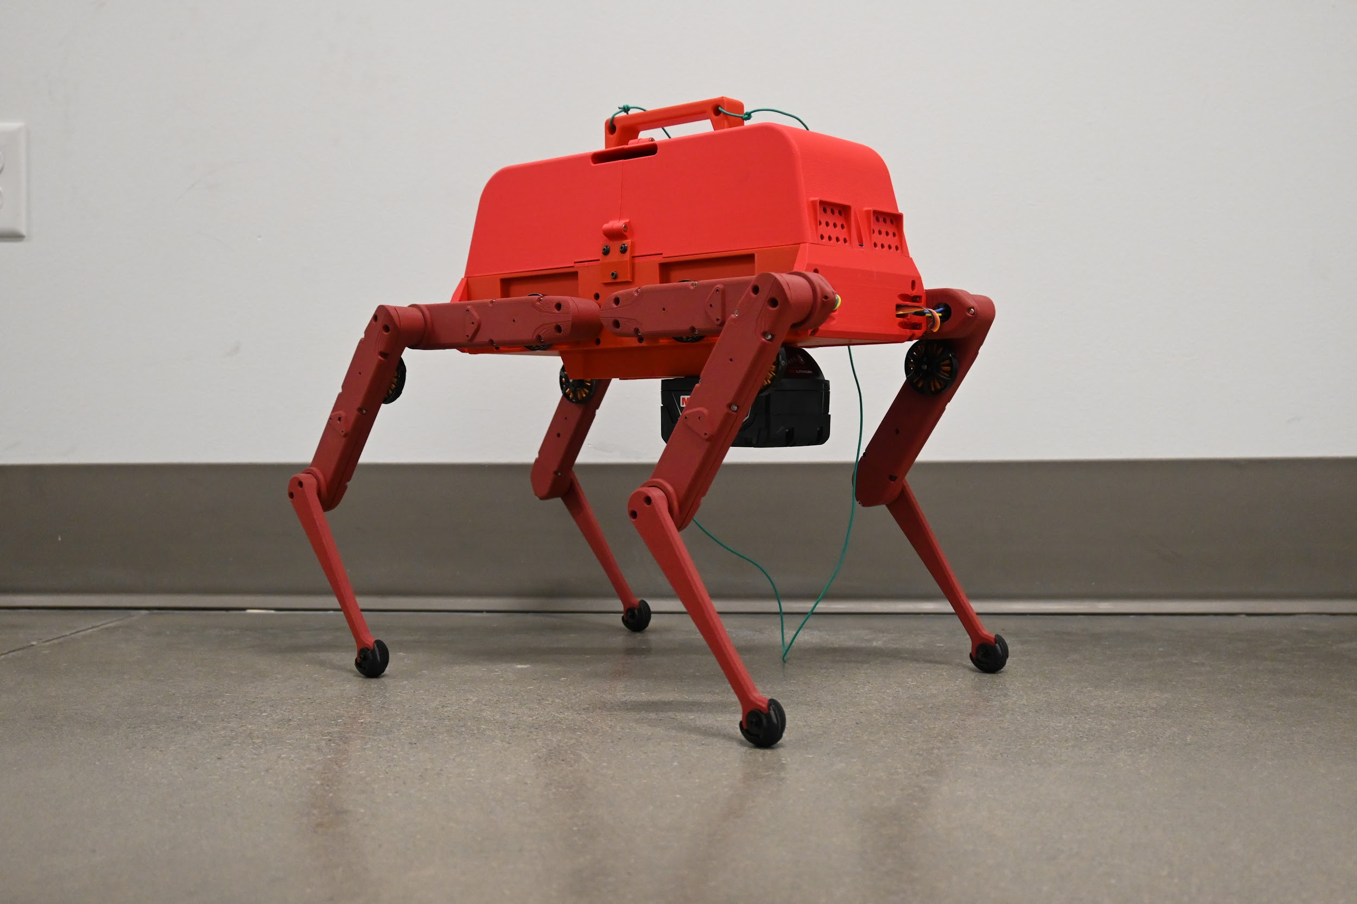

**Executive Summary**

The Quadruped Robot for Smart Agriculture project aims to develop an open architecture robotic research platform for agricultural applications. Quadrupeds can operate autonomously in diverse environments to perform tasks such as field inspection and soil sampling. While industrial quadruped robots can be purchased, they are insufficient for research due to their closed architecture, which restricts user access to low-level control over the robot’s functions. The goal of this project is to create a robot platform that can be iterated on in the future with an emphasis on providing the physical prototype with a well-documented code package to allow for a seamless transition for future teams to work on.

The primary objectives of this project are to build an eight degree of freedom quadruped robot with software that runs on the Robot Operating System (ROS) 2 Humble, features wireless control, contains an onboard power system, has all the electronics enclosed, costs under $6,000, and has the documentation needed to replicate the robot. The project so far has spent $4,431.90, well below the $6,000 budget. The design must also meet specifications such as structural integrity, reliable motor torque, and accurate inertial measurement. Eventually, a field-ready robot could include manipulators, advanced navigation, and additional sensors. However, these aspects are out of the current scope for this semester.

Our team employed finite element analysis (FEA) to validate leg strength, achieving a safety factor of 5.7. All static load motor tests met our torque goals, but in dynamic testing, they were unable to support the robot continuously. Dynamic testing showed a mismatch between the maximum allowable power and actual power output, leading to the robot not being able to output its full torque. Additionally, belt slippage issues are causing the robot to destabilize and collapse.

To date, several milestones have been completed, including robot assembly, ROS2 interfacing, wireless communication, leg actuation, and primitive movements (stand, sit, and step). However, challenges persist in unaided continuous walking due to hardware failures. Our efforts have culminated in a walking robot prototype and a cohesive control package for the robot based on ROS2 Humble. The team’s goal is to prepare users and future researchers for a seamless transition into working on and further developing the robot platform.

**Acknowledgments**

All the team members are very grateful to Dr. Shad Roundy and Dr. Kam Leang for their mentorship in this project. Their expertise and guidance were invaluable in creating this robot.

1. **Design Requirements**

The robot’s design requirements were set by the sponsor's needs during in-person meetings. These requirements can be seen in Table 1. Requirements were chosen based on the need to integrate with their current laboratory and research projects. Most importantly was the ability for future researchers to access and modify low-level systems via ROS 2. The robot needed to be untethered both from power and control in order to perform remote field testing. With the expectation that the robot may experience the elements, the internal electronics needed to be enclosed. The target cost was determined from both meetings with the sponsors as well as other potential end users. The cost, set at $6000, is more than some off-the-shelf robots, but much more affordable compared to other fully open-architecture products.

Table 1: Design Requirements

| Must be part of scope | Optional Scope | Not included in Scope |
| --- | --- | --- |
| 1. Runs on ROS 2 Humble 2. No tether; wireless control 3. On-board Power System that can run for minimum 30 minutes 4. Enclosed electronics   –weathertight   1. Easily carryable (handle) 2. Utah red colors 3. Total robot price < $6000 4. Include sufficient documentation to replicate robot | 1. Can navigate to four points in a field. 2. Rebuild chassis with stronger materials during second semester (fiberglass infused ABS) | * Additional actuators * Additional sensors * Efficient walking * Manipulators * Radio beacon triangulation * 12 degrees of freedom |

1. **Design Specifications**

Design specifications were chosen to ensure that the robot has the basic requirements to allow for future locomotion over rough terrain. Our team advisors contributed their expertise in selecting goal values. No metrics were determined via simulation, all achieved values are the result of real world physical testing from the prototype.

The ability for the robot to stand and walk under its own weight was the most important specification we had to meet. If the robot does not have the power to stand, then there is no way for us to meet any other design specifications. Further, we want it to be able to support an additional load equal to 50% in order to meet ISO standards for self-propelled agricultural machines. Under static loading we were able to add an additional 5-pound load to the robot without failure, but once it starts moving, it can no longer sustain that weight.

The robustness and strength of the robot chassis and support were an essential specification we had to meet. We need to be sure that the materials can also support the robot, not just the motors. We ran an FEA analysis last semester on the lower leg segment components and determined we had a factor of safety on physical strength of 5.7. The details of this analysis are found in Appendix B.

The team knew that staying stable on rough terrain that may be encountered in a field would be difficult if the IMU had a low resolution. The IMU includes an accelerometer and gyroscope, which are used to calculate the absolute orientation of the robot using the acceleration and rotational speed. The greater the resolution, the easier it is to maintain stability. It was decided to match the specifications in the Open Dynamic Robot Initiative (ODRI) project on this count. The IMU integration contributes to the response time as the baseline control is determined from the orientation. To account for this, the IMU can respond in 200 ms or less to respond to sudden shocks and elevation changes. Real-world closed-loop tests were not completed due to actuator module hardware failures.

The robot is expected to eventually operate in large fields. Our advisors directed us to target a minimum runtime of 30 minutes to accommodate this. Under a static standing test, we used approximately 25% of the battery in 10 minutes and 32 seconds, corresponding to approximately 42 minutes of runtime. Due to the torque required for static standing, this is a close approximation to power consumption during dynamic walking.

One reason why our team advisors gave funding for this project was to have an open-architecture quadruped robot to use in the lab. The biggest obstacle to research being done with an off-the-shelf quadruped robot is that they generally do not allow users access to or modify the code, or have an additional multi-thousand-dollar cost for the code to be accessed. None of them support hardware modification. Consequently, while it was important for our robot to stay within the $6000 budget, it was more important that the robot was composed of open hardware, such as the ODrive motor controllers, and open software, such as ROS2. The CAD files we can supply to future researchers also allow for easy modification of the body and actuator designs using a 3D printer.

The robot needs to receive updates and upload information to the end users from the middle of fields. For this to be effective, the robot has to have a wireless delivery range of 1000 ft. With the current setup, wireless range is determined by how far the wifi network it is connected to extends. In other words, so long as the usage area is covered by the same wifi network as the one the control device is connected to, range is not an issue. Using a powerful WiFi router or extenders, the range can be increased arbitrarily.

Table 2: Specifications

| Customer Needs # | Metric | Units | Goal Value | Achieved value | Final Status |
| --- | --- | --- | --- | --- | --- |
| 1 | Ability for the robot to stand | Lbs | >1.5 * total weight = 15.534 | 16.73 | Revised |
| 2 | Robustness and strength of the robot chassis and supports | Lbs | >1.5 * total weight = 15.534 | 16.73 | Complete |
| 3 | Accuracy of inertial measurement | mgs | 0.1 |  | Not yet complete |
| 4 | Response Time | ms | 200 |  | Not yet complete |
| 5 | Robot runtime while all motors are under load | min | 30 | 42 | Revised |
| 6 | Cost of the robot | $ | <6000 | 4431.90 | Complete |
| 7 | Wireless Delivery | ft | 1000 | Router dependent | Complete |

1. **Engineering Standards**

The standard that applies to our project is the ISO standard for agricultural machinery. It is used for self-propelled machines of various types, which our project falls under. This standard determines the load-bearing capacity our robot needs to support. It states that the mechanical supports on the robot (in this case, the legs) should be able to support 1.5 times the target load. While our material choices can meet this requirement, our motors can only achieve this under a static load. The standard does require the robot to support the extra weight while moving, so we cannot meet this specification. Other specifications in this standard that we considered are electrical system specifications, which require our electrical systems to be protected from fluids and kept away from moving parts and sharp edges. We have designed the body with this in mind, both for this specification and our user needs. Further, it is necessary to include an emergency stop system, which we have, though it is not marked traditionally.

More information on this standard can be found here:

<https://compass.astm.org/document/?contentCode=ISO%7CISO%204254-1%3A2013%7Cen-US>

1. **Final Design**

The design of the robot includes the following subsystems: the control system, power system, chassis, and legs.

**Control System**:

The control of the robot is handled by the onboard computer. The Orange Pi 5 was selected due to its ability to run ROS2, onboard CAN bus support, and its superior CPU compared to other single-board computers. A USB WiFi dongle allows the computer to access WiFi. The SSH protocol is used for wireless communication with the end user. The Orange Pi is paired with a CAN transceiver for internal serial communication with motor drivers. The CAN communication protocol allows the Orange Pi to control all eight motor driver modules simultaneously over a single serial communication bus. The ODrive S1 was selected as the motor driver due to its ability to handle PID servo control of three-phase brushless motors and its open-source nature. The fact that position control is handled “off-board” from the Orange Pi frees up limited CPU usage for less control latency. The ODrive S1 drivers are capable of 20A of current each, making them more than sufficient.

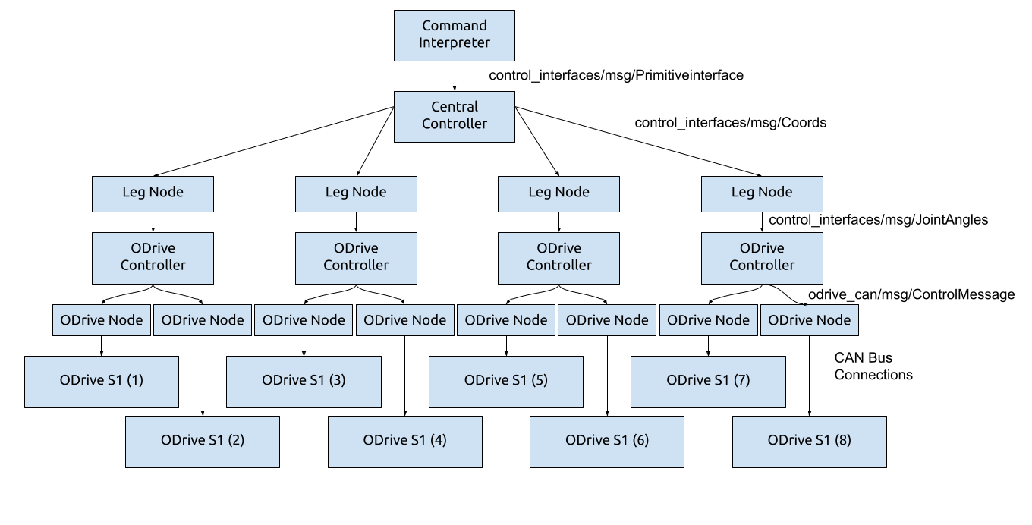

Figure 1: Block diagram of the control system.

The user can send commands to the Orange Pi via SSH, which are then interpreted by a ROS node to determine what motions to execute. The tree of how this works can be seen in Figure 1. Initially, a ROS message is sent over SSH to the command interpreter which then passes a type of motion to the central controller. That controller then generates a ramp for each leg of how to move to execute that motion, then passes it to each leg node. The leg nodes then perform inverse kinematics to convert their target positions to joint angles. To ensure maximum responsiveness, all of this is written in C++. The joint angles are passed to the ODrive controller which translates them to a format the ODrive CAN nodes understand. This layer is written in Python for compatibility. A diagram of the single motor hardware control setup using the ODrive is shown in Figure 2.

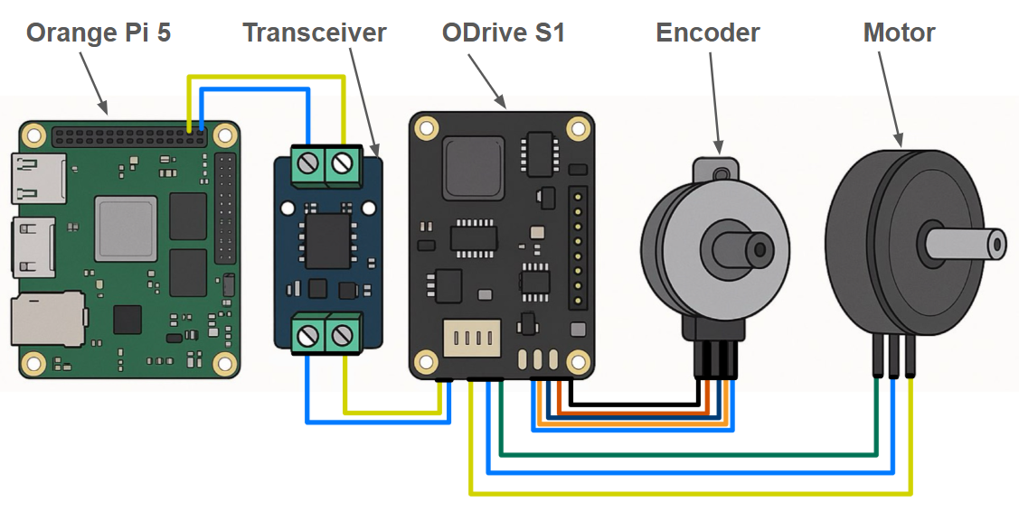

Figure 2: Single motor control setup using ODrive.

**Power**:

The battery source is a Milwaukee M18 battery commonly used for power tools. It was chosen for easy integration into our advisors’ laboratories, their high capacity of 5 amp hours, 20A max output, easy removal for charging, and integrated safety features. It is linked to a power distribution board which sends 18V to each motor. They also power a 18VDC to 5VDC power supply connected to the Orange Pi. The Orange Pi can output 3.3V or 5V signals to peripheral components, such as the IMU, as needed.

**Chassis**:

The chassis houses the electrical components such as the IMU, ODrives, Orange Pi, fuses, braking resistors, wires, and an 80mm fan in a weather-tight enclosure, with vents for airflow. The legs are mounted on the sides of the chassis. The ODrive and Orange Pi mounting brackets were designed to allow the components to be easily removed for access to the wiring.

The battery hangs down below the chassis, attached to it by the Milwaukee snap in adapter points. The chassis is entirely 3D printable. The current prototype is printed from red PLA, but other more durable filament options can easily be printed using the 3D model files. The chassis internals can be viewed in Figure 3. The 3D rendering of the chassis cover and chassis can be viewed in Figure 4.

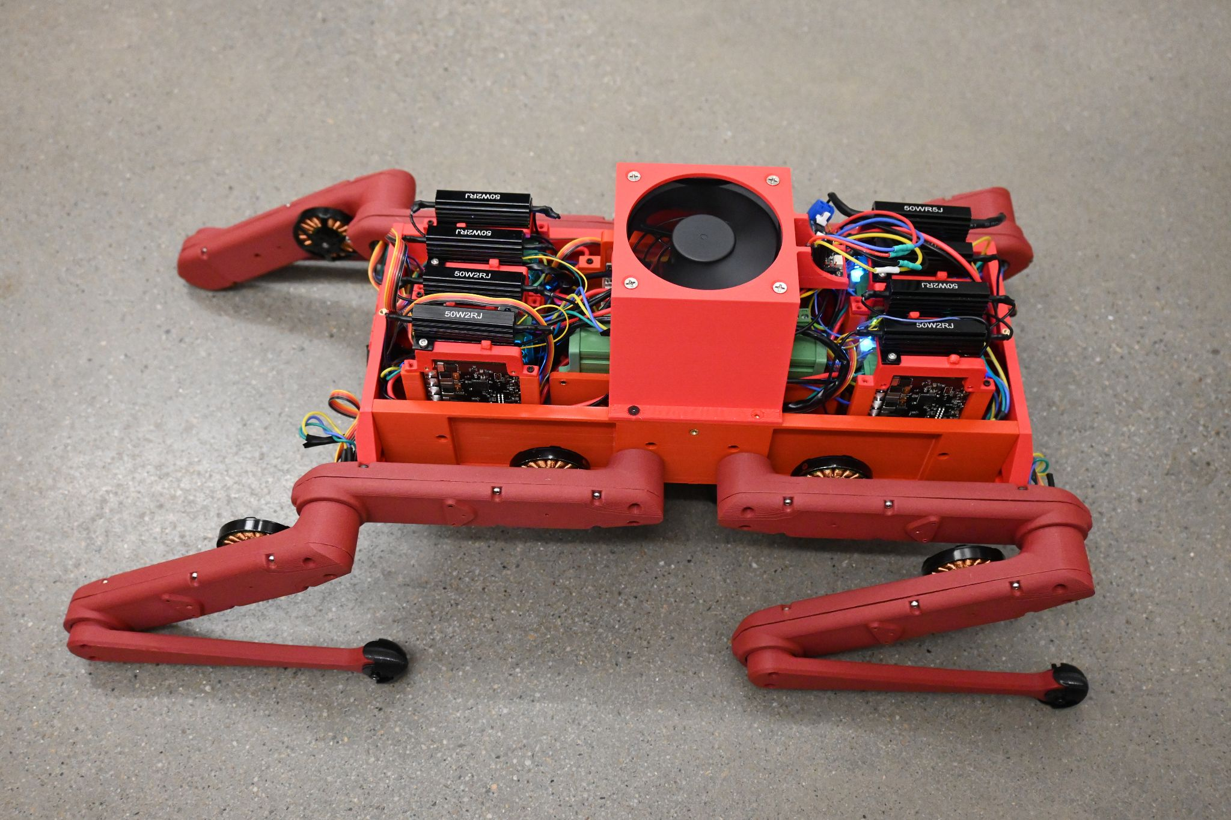

Figure 3: The internals of the robot.

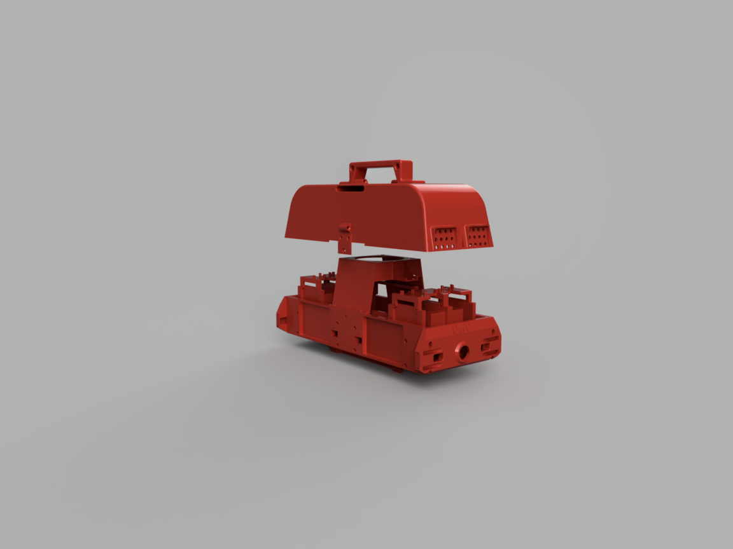

Figure 4: The 3D rendering of the chassis and cover.

**Legs**:

The legs are composed of three parts: the upper leg, middle leg, and lower leg. The upper leg is fixed to the body on the sides of the chassis by four M3 screws that are connected to the heated inserts in the chassis. The upper leg houses all the components necessary for the actuation of the middle leg, and the wires for the middle leg run through it. The middle leg is connected to the upper leg by two M3 screws, it houses all the components necessary for the actuation of the lower leg. The actuator design is identical to that of the upper leg. The lower leg is connected to the middle leg by two M3 screws, it does not house any components and is a solid part.

All leg components are made of CF-PLA at 40% infill. Due to the likelihood of the bottom leg contacts breaking, the bottom legs are printed at 100% infill. 16 wires are routed from the leg to the body, 8 for each motor and encoder pair. There is a series of belts and gears that provide a 10:1 gear ratio to ensure sufficient torque. The actuator design is copied directly from the Open Dynamic Robot Initiative, and can be seen in Appendix C, as part of our original scope.

The robot legs have 3D printed hemispherical “shoes” made of TPU, so they can be easily replaced once worn down. These “shoes” provide additional traction for the robot.

1. **Performance Verification**

Our performance verification involves the following verifications. Of the seven design specifications, four have been tested or evaluated. Those are numbers 1, 2, 5, 6, and 7.

1. The robot can walk under its own weight and can stand with a payload of half its own weight.

To verify that we could meet standard 1, we constructed a test stand for one leg actuator, commanded it to 90 degrees for the worst case load scenario, then added weight to it until it could not support itself and moved. The results were that, at the worst case angle, the robot could support 495 grams at 5 amps. This corresponds to a torque of 0.714 Nm, which we can extrapolate to 2.142 Nm per motor at 15A. We can do this because torque and current are directly proportional, so in the final battery-powered configuration of our robot drawing 15 A per motor, the torque would be 3 times what we tested. This then converts to 3.16 lbs per motor, or 12.64 pounds of lifting force total. With the full robot, we were able to lift an additional five pounds on top of the robot’s weight of 10.356 pounds. This beats our expectations and confirms that we can meet the ISO standards for weight capacity under a static load. However, the robot required support equal to about half its weight to allow it to lift a leg off the ground without losing stability. This prevents it from meeting the ISO standards under dynamic loading conditions.

Though the motors are rated to support 9A, our live testing resulted in serious motor heating at currents as low as 3A. This phenomenon only occurred in certain motors, leading us to suspect a fault in either the motors or the drivers. This limitation allows the robot to stand for short periods but prevents us from drawing enough current for effective unsupported walking, as pulling more risks melting the legs.

A consequence of using ODRI’s design is notable belt slippage under dynamic loading. Whenever an actuator experienced a sudden load, such as taking a step, the belts would skip. This both creates a mismatch between the leg position and the encoder measurement and causes the motor drivers to panic and shut down. The issue seems to stem from the increased weight of the robot compared to the original ODRI design.

1. The robot’s frame to support itself can support an additional weight equal to 50% of the robot’s weight without any yielding.

The robustness of the robot’s bottom leg segments is tested in Appendix B in a preliminary FEA simulation to verify its feasibility. After building the robot, the rigidity and strength of the leg segments are tested by putting weight on the leg segments until failure. The motor reached its current limit before any yielding occurred, satisfying the requirement. After the completion of the robot prototype, the robot was proven to be able to push itself up with a load of 1.5 times its own weight.

1. The accuracy of the inertial measurement unit (IMU) must be within 0.1 mG.

The IMU’s data is translated to acceleration and gyroscope data automatically by the Adafruit LSM6DSOX library. The accuracy must be measured in case subtle changes in orientation causes the robot to be lopsided on flat ground.

The IMU has not been tested with the robot in closed-loop control. External testing showed the LSM6DSOX Adafruit IMU to get the acceleration to 10-2 m/s2, which is the equivalent of 1 mG. Static testing showed noise in the acceleration readings fluctuated between ± 2 x 10-2 m/s2, which on face value does not meet the constraint. As the robot walks on land, a small deviation in orientation should not be an issue. Walking tests will need to be performed to find out if the noise prevents the robot from stabilizing.

1. The response time should be less than 200 ms.

Due to the focus on walk testing, this specification has not been tested with the whole robot. In component testing, the Python-based code runs at a minimum speed of 100 ms. While this meets the constraint, Python has significant performance overhead and may impact the overall response time of the robot. Alternative tests with C++ code yielded order of magnitude improvements, informing the decision to use C++ for control except for where Python was necessary for compatibility.

1. The robot has at least 30 minutes of constant runtime.

A dynamic test has not been complete due to issues with robot walking. Its instability prevents it from maintaining even a supported gait for a meaningful amount of time. However, a static load test drained 25% of the battery in 10 minutes and 32 seconds. This gives a runtime estimate of about 42 minutes.

1. The total cost of the robot is less than the budget of $6000.

The current cost of the robot is $4,431.90, which is well below the $6,000 available. Everything has been ordered for the construction of the robot, not including backup components. Total ordering information can be found in Appendix 1.

1. The range of the robot is within 1000 feet.

The wireless delivery range is limited by components outside of the robot, but for testing at the U we would comfortably exceed 1000 feet as the U’s network extends well beyond that range.

1. **Budget**

The total budget set out for this project is $6000. Our budget was separated into components to construct the physical robot (actuators, encoders, structure, etc.) and the untethering components. We expected to spend $5000 for the construction of the body and $1000 for the untethering components.

The total amount of money spent on this project was $4,431.90. This is well below the $6,000 available. The most expensive items used in this project are the AEDM-5810 5000 count-per-rotation encoder wheels from PWB Encoders for a total of $1245.77. The second highest cost is the ODrive S1 brushless motor controller boards for $1,490 total. The breakdown of the budget is provided in Appendix A.

1. **Future Work**

Future work should focus on remedying the issue of belt slippage, a problem that can destabilize the robot and cause drift in the joint position measurements. Any continuation of the project would need to start with a redesign of the actuator modules to improve rigidity and raise the torque output. Full integration of the IMU would help with some of the balancing concerns, and building custom battery packs could reduce weight and raise the overall robot runtime. The last improvement to the project would be upgrading the system to twelve degrees of freedom. This would make it more complex to control but improve the robot’s movement capabilities. Future teams should also look into advanced features of the ODrives which require manual implementation of a CAN communication system.

1. **Project Deliverables**

It is essential that proper documentation is given to allow future users the ability to modify the platform we have developed or replicate it. Further, we need to provide a working prototype to build on directly.

Final deliverables:

* Final assembled robot (Complete, April 22nd)
* Email\flash drive with all code and 3d printed part models (In Progress, April 22nd)
* ME EN 4010 Final Report, poster presentation files (Complete, April 22nd)
* Documentation for setup and code use (In Progress, April 22nd)
* Bill of Materials (Complete, April 22nd)
* Videos of robot functionality (Complete, April 22nd)
* Any spare or extra parts and materials (In Progress, April 22nd)

1. **Conclusions**

In conclusion, the quadruped robot for smart agriculture is an open-architecture quadruped robot. It is a fully open-architecture eight degree of freedom robot which can be communicated with wirelessly. In its current form it carries enough on-board power to operate for extended periods. The robot demonstrates sufficient control capabilities to stand and sit. It demonstrates sufficient strength to bear a weight of one and a half its total weight. In its current state, the actuator modules suffer from hardware limitations which limit their ability to sustain the dynamic loads of walking. Over all, the project is ready to serve future researchers working on quadruped control. All documentation will be recorded and given to the following team. A prototype has been built, with all necessary hardware present and working, to demonstrate the feasibility and concept of such an endeavor.

**Appendix A: Bill of Materials**

| **Part** | **Supplier** | **Quantity** | **Price Individual Part** | **Price All Parts** |
| --- | --- | --- | --- | --- |
| M3 x 5 SS (50 pcs) | [mcmaster](https://www.mcmaster.com/products/screws/flat-head-screws~/flat-head-profile~standard/system-of-measurement~metric/metric-316-stainless-steel-hex-drive-flat-head-screws/) | 1 | $5.09 | $5.09 |
| M3 Screw and Nut Assortment | [Amazon](https://www.amazon.com/dp/B0B51BFSWZ/ref=sspa_dk_detail_2?psc=1&pd_rd_i=B0B51BFSWZ&pd_rd_w=AOTFq&content-id=amzn1.sym.8c2f9165-8e93-42a1-8313-73d3809141a2&pf_rd_p=8c2f9165-8e93-42a1-8313-73d3809141a2&pf_rd_r=FJY2F30S8SZP8D12B2QF&pd_rd_wg=l9asT&pd_rd_r=594f0113-1cfb-4b98-894f-7151754a2d90&s=hi&sp_csd=d2lkZ2V0TmFtZT1zcF9kZXRhaWw&smid=A23XVIPJ96UME3) | 1 | $7.99 | $7.99 |
| M3 x 4.5 Helicoil (10 pcs) | [mcmaster](https://www.mcmaster.com/products/threaded-inserts/threaded-inserts-2~/stainless-steel-helical-inserts-9/) | 3 | $8.98 | $26.94 |
| M3 x 6 Helicoil (10 pcs) | [mcmaster](https://www.mcmaster.com/products/threaded-inserts/threaded-inserts-2~/stainless-steel-helical-inserts-9/) | 3 | $11.35 | $34.05 |
| Brushless Motor (2pk) | [T-Motor](https://store.tmotor.com/product/mn4004-kv300-motor-antigravity-type.html)* | 4 | $145.90* | $583.60* |
| Bearing Output Shaft | [123-Bearing](https://www.123bearing.com/bearing-housing/deep-groove-bearing/single-row/61705-2rs?gad_source=1&gclid=Cj0KCQjwiuC2BhDSARIsALOVfBLTtf_wx8QmTYzEErM5VmS_L0-OCCcSK4K_FfiNdRsoK2PocKlsLKQaAqzOEALw_wcB) | 16 | $5.02 | $92.42 |
| Bearing Motor Shaft and Center Shaft | [123-Bearing](https://www.123bearing.com/bearing-housing/deep-groove-bearing/single-row/mr84-ezo?gad_source=1&gclid=Cj0KCQjwiuC2BhDSARIsALOVfBLP6zc2D7WI78cAX-wvPuipUXAhRfhm4ViEobpSNPHtPp2gaRZUCqoaAl5xEALw_wcB) | 24 | $8.03 | $166.56 |
| Bearing Timing Belt Tensioner | [123-Bearing](https://www.123bearing.com/bearing-housing/deep-groove-bearing/single-row/683-zz-ezo?gad_source=1&gclid=Cj0KCQjwiuC2BhDSARIsALOVfBJvnXByl5luDD8K-qQIBbE7xVEqaPmOi-kKv8cbh-WROOkpH6PaLOsaAo3hEALw_wcB) | 16 | $6.24 | $112.64 |
| Timing belt first stage | [Belting Online](https://www.beltingonline.com/at3-gen-iii-synchroflex-timing-belts-4593) | 8 | $5.96 | $47.71 |
| Timing belt second stage | [Belting Online](https://www.beltingonline.com/at3-gen-iii-synchroflex-timing-belts-4593) | 8 | $8.94 | $71.53 |
| Encoder Kits | [PWB](https://github.com/open-dynamic-robot-initiative/open_robot_actuator_hardware/blob/master/mechanics/general/details/20210407_ODRI-KIT-new.pdf) | 8 |  | 1,245.77 |
| M3 x 16mm Plastic Screws (20 pcs) | [Amazon](https://www.amazon.com/uxcell-Plastic-Phillips-Machine-Washers/dp/B0B7RGWSQQ?th=1) | 1 | $8.89 | $8.89 |
| 20 AWG Cu Wire (6 color, 50 ft each) | [Amazon](https://www.amazon.com/NAOEVO-Silicone-Electrical-Breadboard-Automotive/dp/B0CML8MQD5/ref=sr_1_10?crid=1TA2ELK27H6TI&dib=eyJ2IjoiMSJ9.29ewf5GYcMdjyDUN8HnY_R4B-rfEHBCaiJl53iv3ScEoi3OdrcTeKxtzkR9iC06ah_4DAj5duxLwZcG85xIdfZEHecT4HWAx5E8BjXzCHNALSuJJpRzslGg0_rxZnbBDwovnyk8OEUEaGVuC5is_Uzlg3i2G-RwN0gTqgJagr8n_OavjkvZuMKA-kzJZPCRStBIPKYfHemEY9uRmNfIvDWgYD5uGJ00xMo7oJjBe4pqOsAffs767YavxgEnpjodW7D-sLs0mu3khAtDJWdCvVZ03LU9O7kPiyW6qEaGkoDs.HEdvn_m6ZMILdNY8iyJL01XLM8ZuS9JF8v-Yw6yQukY&dib_tag=se&keywords=20+awg+copper+wire&qid=1726498191&sprefix=20+awg+copper+wi%2Caps%2C279&sr=8-10) | 1 | $27.99 | $27.99 |
| 26 AWG Cu Wire (6 color, 50 ft each) | [Amazon](https://www.amazon.com/dp/B089CSCY8S/ref=twister_B0DDXRJX1W?_encoding=UTF8&th=1) | 1 | $24.49 | $24.49 |
| 18 AWG Cu Wire (2 color, 25 ft) | [Amazon](https://www.amazon.com/flexible-Electrical-Extension-Stranded-Automotive/dp/B0D12T94T2/ref=sr_1_1_sspa?crid=31AKO6CY3JHEH&dib=eyJ2IjoiMSJ9.YPZ3ddG7MMpGrRNr60X8fJAUrVxr9bNCXnvujCicZWCAOJoEIGaej9OSKZsIxydrb0ml2Mv3DsBDCNc8fZAfJcZlAtBLT2oqXNzBFFNHk2BxiaHy3PQqDQsapKoBRYbhv0ke46lDt-wyslW6gwCpLbhBjNREEMP1DPpkkvVVUfSTl7Df3jm8h8VOMwO8SJiZxB6CNyYVIPA5mhiyX7_A1nKytAYZ-gBJQRmXUAjZ1u23t9bnDMgw1AuTr0J1BzFM7hbs5nrATszlcaJ_b8Av2jpis1I3zGI002gqnLlr-vQ.RK3ZxOd1HNADcvWiFbtCL53ZIe-m84RnuDyTgfLKN4o&dib_tag=se&keywords=Red%2Bblack%2B18%2Bawg%2Bwire&qid=1726501470&sprefix=red%2Bblack%2B18%2Bawg%2Bwi%2Caps%2C219&sr=8-1-spons&sp_csd=d2lkZ2V0TmFtZT1zcF9hdGY&th=1) | 1 | $9.50 | $9.50 |
| Banana Plugs Connector 2mm (30 pcs) | [Amazon](https://www.amazon.com/dp/B0CPWGKM4Z/ref=sspa_dk_detail_1?pd_rd_i=B0CPWGKM4Z&pd_rd_w=an3a8&content-id=amzn1.sym.f2f1cf8f-cab4-44dc-82ba-0ca811fb90cc&pf_rd_p=f2f1cf8f-cab4-44dc-82ba-0ca811fb90cc&pf_rd_r=26TXFCHKE4GYJM2ZQPM7&pd_rd_wg=r3sDs&pd_rd_r=61ed43a5-d0ee-451e-90a7-b5cf4a14207d&s=aht&sp_csd=d2lkZ2V0TmFtZT1zcF9kZXRhaWxfdGhlbWF0aWM&th=1) | 1 | $10.49 | $10.49 |
| Wire Splicer (2, 3, 5 Way) Kit | [Amazon](https://www.amazon.com/GKEEMARS-Compact-Splicing-Connectors-Circuit/dp/B09VSF5TV2/ref=sr_1_5?crid=16RZ8HYZXQUYM&dib=eyJ2IjoiMSJ9._mMNhpr_5VmLhnyGDmDgDbF_UElQfse4fNaLeW86PVhccp87TjoP5QqWpWJ9tpbL1fmYFoobiHzR1N1hUapBKNV_rM-tGsKkE2I45E0umgF17f12xYNUgOC4vNE7bpBOVz44s9xhe3pslNtgEFIYGuI98wiJS4QMbL_67zBQHPOq-WTwFW_st5TlO0BB5rlTjB4Ydf3D4Pl2m1nclThpx9sUL1RhLW8H21np6NeGpD8.uJd2hhrnEss9ua4j--Q3mm5nTCZEy8uoq87dbxJuVCI&dib_tag=se&keywords=2+channel+wire+splicer&qid=1726501530&sprefix=2+channel+wire+splicer%2Caps%2C175&sr=8-5) | 1 | $14.98 | $14.98 |
| Amass XT30 Connector Male Female | [Amazon](https://www.amazon.com/10Pairs-Upgrade-Connector-Female-Battery/dp/B08P5HVMYT/ref=sr_1_2?crid=3SH2CAE14KAKY&dib=eyJ2IjoiMSJ9.zBJ5uSMKYC9JtRNpsEEZ64US5LSFP-stYkTenr2RdRrQmLH7IlTLO6Aa05vvCi30tjCnfef_c2QB9-bPYZpykJoYJAe_HfPfnE_RQQF1QcJThZx87MbpfckApasHddpOWMHd5MaHerAUE0w8ElXpWOzcWw8lF_K9b3CyP7Dnf0GEALdhsXjahyW7Ek2WgxGEDB5AqjSF0cj69Jgvd7PFosQYdsau70-ZIYNspZ2v_2M0mPa0wIUg0N44YJ7burFNwNbNZBH0Yf74acpFy9pXHyomW5Doq6xZj6j9Q6CwI3U.DpckSS3gGSHf_w34IUxdY2_CbSoCVWQRqOk_ZuGuQ9M&dib_tag=se&keywords=XT30U+Connector+Receptacle+20+Amps&qid=1726502574&s=hi&sprefix=xt30u+connector+receptacle+20+amps%2Ctools%2C122&sr=1-2) | 1 | $8.58 | $8.59 |
| Ribbon wire 1.27mm pitch | [Amazon](https://www.amazon.com/dp/B07FMCCYBM/ref=sspa_dk_detail_2?pd_rd_i=B07FMCCYBM&pd_rd_w=88LJZ&content-id=amzn1.sym.f2f1cf8f-cab4-44dc-82ba-0ca811fb90cc&pf_rd_p=f2f1cf8f-cab4-44dc-82ba-0ca811fb90cc&pf_rd_r=5VFDQ348VGYY78N4D1NT&pd_rd_wg=is85U&pd_rd_r=27861f3f-6890-462b-b905-59c7dd4bb1a0&s=hi&sp_csd=d2lkZ2V0TmFtZT1zcF9kZXRhaWxfdGhlbWF0aWM&th=1) | 1 | $13.99 | $13.99 |
| 4mm Banana Plug (female adapter) | [Amazon](https://www.amazon.com/Insulated-Safety-Shrouded-Female-Connector/dp/B07KKJQ1Z1/ref=sr_1_3?crid=1MWFGW1O3V7XP&dib=eyJ2IjoiMSJ9.IoBmWpPoFUwzck7nnv7FD3L50U-0GJNZB0LZBSNu9KkGNfZM2-AIrj6_Q9dyKwXwWbYNlIi1hvyRlCvyPOCdbvEMu7p0vlbkR30R9Pdwb1sUyrO-t8VsG3t6ziBQb1vG03wUppC_4NwrVvbfF2bZfpMGULNSb6DSVlP4awKO86ZF9Bd9icQMgVVNha2XDpX9j-mS2Q_krwUqov5TrmfmWrZs_HhdlM9k3lMB1ppEfgk.aSvtam_ieu8dkxMcNgswtsqLFyUxaAxaVmgaYXSaxIw&dib_tag=se&keywords=4mm%2Bbanana%2Bplug%2Bsocket&qid=1726502512&sprefix=4mm%2Bbanana%2Bplug%2Bsocket%2Caps%2C137&sr=8-3&th=1) | 1 | $9.90 | $9.90 |
| 4mm Banana Plug (male adapter) | [Amazon](https://www.amazon.com/Current-Stackable-Connector-Speaker-Adapter/dp/B07GL5BVNH/ref=sr_1_6?crid=1ET5SXUBTQVFP&dib=eyJ2IjoiMSJ9.qXdy7V9X8sEzYBVoC1wsJt40oqc13T48Qzct0zc36Ek1GAQhdzaKEMQOzgtGuwpsAXtGC6YUcCez89YD7cT-104STlsar8LI0IlcSR7oa5DCUeHEYG_KNASeBNsAMUzlywmXMOe_0o1BkVozuEP7fOcov4WTP6Hx7xltb8D5O7f5oU1wz2asY2FkQY4k1WGDY583MxuW5Qy746GJW4JdmcJ2pYMXTOt0b0osEqLIhBQ.aF3RS0MLgydertrMnDmkLQjKh5DDYr-WhO8xh3wnj7M&dib_tag=se&keywords=male%2Bbanana%2Bplugs%2B4mm&qid=1727583122&sprefix=male%2Bbanana%2Bplugs%2B4mm%2Caps%2C265&sr=8-6&th=1) | 1 | 9.99 | 9.99 |
| Pin Header 2,54 mm pitch | Already in the lab | 1 | 1 | $1.00 |
| 12-Bit Ring LEDs | [Amazon](https://www.amazon.com/Stemedu-5050SMD-Individually-Addressable-Raspberry/dp/B0C7CFQXY3/ref=sr_1_11?crid=1BQR8T0AB8SQU&dib=eyJ2IjoiMSJ9.FZsKUMdSkVK99srnTU0pVxw4OXvPTb4XQ4jZdE8ZN2j5efNoX430BpD0koLUmtfFXYN5vim5Z3FBu0M5MrC7Jw3_Q6qgaHXeQGZApazkpNopYfqeW6zVl65hAVzdNhdRvNDoQIIUxGtTAJ-RBdCTZcp3_5DIUPtLwze1ysUmGqmvXmrBIeSSQL1ypfjli5AgvAc7Ji-gBOM9foaW32XM9szr-ELjT57NiAHZFVQ99BILN-49H--rMvFlRSiXDGyfHczJFme9_oaA32k8BbV8XzBsQZUoL94wwbCoHbht13M.U2wcBtJ3iH_TUaJna3eywbFMwn2-pYXwDMtHLwZXHxI&dib_tag=se&keywords=neo+pixel+led&qid=1726502968&sprefix=neo+pixel+led%2Caps%2C144&sr=8-11) | 1 | $8.99 | $8.99 |
| Right Angle Pin Header | Already in the lab |  | $0 |  |
| Orange Pi | Amazon | 1 | $127.99 | $127.99 |
| CF-PLA | [Bambu Labs](https://us.store.bambulab.com/products/pla-cf?variant=41145212076168) | 2 | 34.99 | 69.98 |
| ODrive S1 | [ODrive Robotics](https://odriverobotics.com/shop/odrive-s1) | 10 | $149 | $1,490 |
| J11 Connector | [Digikey](https://www.digikey.com/en/products/detail/jst-sales-america-inc/PUDP-30V-S/1989468) | 12 | $0.65 | $7.80 |
| J11 Crimp Pins | [Digikey](https://www.digikey.com/en/products/detail/jst-sales-america-inc./SPUD-002T-P0.5/1989510?utm_adgroup=&utm_source=google&utm_medium=cpc&utm_campaign=Pmax_Shopping_DK%2B%20Supplier_ITECH&utm_term=&utm_content=&utm_id=go_cmp-21147141757_adg-_ad-__dev-c_ext-_prd-1989510_sig-Cj0KCQjw99e4BhDiARIsAISE7P__hMisvvNMTYve_Widx9-1Kzb1rRqg2rn7jBG9FWOGS_O1GTm0Es4aAvcIEALw_wcB&gad_source=1&gclid=Cj0KCQjw99e4BhDiARIsAISE7P__hMisvvNMTYve_Widx9-1Kzb1rRqg2rn7jBG9FWOGS_O1GTm0Es4aAvcIEALw_wcB) | 450 | $0.032 | $14.328 |
| J16, J17, J1 Pre-crimped connectors | [Amazon](https://www.amazon.com/Pre-Crimped-Connectors-Pixhawk2-Pixracer-Silicone/dp/B07PBHN7TM/ref=asc_df_B07PBHN7TM/?tag=hyprod-20&linkCode=df0&hvadid=693418895682&hvpos=&hvnetw=g&hvrand=4381951338110865521&hvpone=&hvptwo=&hvqmt=&hvdev=c&hvdvcmdl=&hvlocint=&hvlocphy=9197915&hvtargid=pla-758799606130&psc=1&mcid=f08e179d375037168aad137e2e6f92bd) | 1 | $18.99 | $18.99 |
| SanDisk 32GB microSD | [Amazon](https://www.amazon.com/SanDisk-Ultra-UHS-I-Memory-Adapter/dp/B00M55C0NS) | 1 | $7.85 | $7.85 |
| Braking Resistors (5ct) | [Amazon](https://www.amazon.com/Comidox-Aluminum-Housed-Wirewound-Resistor/dp/B077ZMYNBF/ref=sr_1_6?crid=227N982AMU5B8&dib=eyJ2IjoiMSJ9.dHbY6J3ibn8mHLeRXipnnLTuecg0ziLNuA1FNgtf5xhV93zw69fke4d5VXEcB6VGBhRAbdM2D_HV6zfZrm3b2VFT4YYFu_vle5FLbB4DaoBLs5z5Nc94VrxGRqZ3da1M4lROg77PBkcvmsJXcQosZPAnUTCPkaAfxtpB7yyUtpov2oZ0IluW7QAtucio7JcjPEgTIA-V2AbV8bf35CltpYi-NFFVqUR1-3boeU4ma4g.b58RKqC9nPXQQhilnVGzEkGTmCT9PAnatVE1ple4lhE&dib_tag=se&keywords=braking+resistor+2+ohm&qid=1729551643&sprefix=braking+resistor+2+ohm%2Caps%2C123&sr=8-6) | 2 | $9.99 | $19.98 |
| IMU 6-Axis Board | [Adafruit](https://www.adafruit.com/product/4438) | 1 | $11.95 | $11.95 |
| Encoder for Testing | [Digikey](https://www.digikey.com/en/products/detail/broadcom-limited/AEDM-5810-Z12/5357134) | 1 | $65.90 | $65.90 |
| Heat Set Insert tip Tool | [Amazon](https://www.amazon.com/Vertical-Pressing-Machine-Inserts-Printing/dp/B0D22MLFMD/134-3460923-3496503?psc=1&sp_csd=d2lkZ2V0TmFtZT1zcF9waG9uZV9kZXRhaWxfdGhlbWF0aWM%3D) | 1 | $38.99 | $38.99 |
| M2.5x6 Socket Head Screws | [Amazon](https://www.amazon.com/iexcell-Thread-Stainless-Socket-Screws/dp/B0D7S1CM87?crid=233EHG2WMXODK&dib=eyJ2IjoiMSJ9.Is1H24QO1RN3gk6jRgBSs1WB_x7IhoWRieee0aBfaMQFYXXB65wcHNun4vjtS7TqsKv3Otxi3A3oxYrNpyAmQU6unNuoC0Tj0oO2AafoDt6xrJqegEaE02BxKRXlnUxpkE_kn_cphclF2PV708tuaf4j8fU_q3VwVrcHwUJPcylgVem2oND1ctplFryhlQPXAvcYUvUerHiOYvcCA_Otuw.ibpmFegwmRuj1lbQ-wTbze02O5wGf2pm7e2YSfA3C5Q&dib_tag=se&keywords=m2.5+6+socket+head+screws&qid=1737650678&sprefix=m2.5+6+socket+head+screws%2Caps%2C192&sr=8-3) | 1 | $7.28 | $7.28 |
| M2.5x10 Socket Head Screws | [Amazon](https://www.amazon.com/iexcell-Thread-Socket-Screws-Finish/dp/B0DDXNQ7GT?crid=FSM0ZXU1QOVM&dib=eyJ2IjoiMSJ9.o49bkeFSTK8fJUICLju_SRmVyORDewl3b5Bd09KOZvCjXRcp9g6mbjAsh7FbKpcD55SlxRtrnUjXF4gKOocIflg9NXUtmzK85dDVoLC7A33FtzDbwYoyxlz14xa8P24n0z5CVJ4OJalClznnbJml9IuXS933zD1G_dcAVjY9XrQYztBOHFqqVgYHfx01UteoRXOZ6ny-JuK7FrxdJ_INZpRbj3GXJ6ERutFT2-W0d_k.sw-QcQqAGbKDsoqQ0kVukJBhiRVW-ZHWDACBFvyZAoQ&dib_tag=se&keywords=m2.5+10+socket+head+screws&qid=1737938135&sprefix=m2.5+10+socket+head+screws%2Caps%2C239&sr=8-6) | 1 | $6.28 | $6.28 |
| Untethering Components | | | | |
| USB-C Buck Converter | [Amazon](https://www.amazon.com/dp/B0CRVW7N2J?ref=cm_sw_r_cso_cp_apin_dp_2XNSHGX0HKXFAXDH611K&ref_=cm_sw_r_cso_cp_apin_dp_2XNSHGX0HKXFAXDH611K&social_share=cm_sw_r_cso_cp_apin_dp_2XNSHGX0HKXFAXDH611K&peakEvent=4&starsLeft=1&skipTwisterOG=1&th=1) | 1 | 9.99 | 9.99 |
| Spade Crimp Terminals | [Amazon](https://www.amazon.com/Baomain-Male-Spade-Quick-Splice-Crimp-Terminals-6-3mm-Crimp-Connector-Non-Insulated-Pack-of-100/dp/B01MQ332R6/) | 1 | 6.59 | 6.59 |
| Distribution Board | [Amazon](https://www.amazon.com/Channel-Pluggable-Terminal-Distribution-HCDC/dp/B0C72HZPTP?th=1) | 2 | 30 | 60 |
| WiFi 4 Dongle | [Amazon](https://www.amazon.com/GenBasic-Wireless-Network-Dongle-Adapter/dp/B0BNFKJPXS?crid=10XWOEG0Z2DVO&dib=eyJ2IjoiMSJ9.qyvqFwkCgNNEMA0iz_hZeLJ7iI7B90OGqnaykpTB4DFSAzTjmkuISS1wSZQy8BWm0h5bWioV8FSrvWW3K5HhwsttzPxdr7eXgFcvSzcxJJG7lrK40bucua1ZRdumGjnbhNImigRf3i26UszN7-oX-pt-acy3BORxc1brkI_qW9rfHet80z37kdYnoSo4b2IQrkHTKIg8WPiR-JvoXfBruyW_-qJvNn361pw9fdi-8_c.Ke3--0LDOaoh4k6ZdS8UZtk10IZncWNlf1i3JLKPpRU&dib_tag=se&keywords=usb%2Bwifi%2Bdongle%2Blinux&qid=1733170991&sprefix=usb%2Bwifi%2Bdongle%2B%2Caps%2C134&sr=8-4&th=1) | 1 | 10 | 10 |
| 2-Pack Milwaukee 18V 5Ah | [Amazon](https://www.amazon.com/Milwaukee-48-11-1850-Batteries-48-11-1852-pack/dp/B09NNHN8S8?crid=1M3K82SDBMQR6&dib=eyJ2IjoiMSJ9.5a4kmB4d_V2eoyB2q7cNtfl3ly2CrUwbtJWeUhkfzxd8TBpUdA0ix1kQnfTePThY6MeB1tZTneYP-GvqaDYqjOjYHwG4OCCzYR0NXfgNd-j1oL1kOAOehA5E-53KlQcaVAsg2himRwIO0YxyW_GuLd3kw64DgEgqogEpa3VTQAi2lDHlBvIN-5mLoWOJ0EcJYC1o2znYohNR8rWebGMU7Iflk7DAocpgSbGqa4PulV4MplxtiWdS6VlgawL30ZAHHJe-bdnVgZ5xZuVNQbiyMHk01JTWTjxdTWc8gfM3wCA.m_KrFAvdoBkoZZKLgooPg3IBBa7Bbb9N4iCgyll5nGs&dib_tag=se&keywords=milwaukee%2Bbattery%2B5%2Bah&qid=1733169226&sprefix=milwaukee%2Bbattery%2B5%2Ba%2Caps%2C246&sr=8-1&th=1) | 1 | 128.98 | 128.98 |
| 2 Port Milwaukee Charger | [Amazon](https://www.amazon.com/Milwaukee-48-59-1802-Simultaneous-Rapid-Charger/dp/B084D7B58S?crid=27B6HG9P6K4DG&dib=eyJ2IjoiMSJ9.qLpFINLgdD5eSYjSkM5uHtK1z_Pw0uETF48iJQV4fFkto73m_AOXUzKK0haVZU2RCxLRHYg-YkS1Lc8mEkL9JPdaPzhdJk-LPrkbN7tY2MoDvuEoV6wtTqf6lPKcxLUHKJ6mHNK7FrhyM1LXo3V3jVyyvZGcDvymCe-TojtKGlYw1vuahqLWKgYfvOH6OwzT9RTe8HMFwBc6kB5IikMzLCnpAAi8EC2GyBJhPcLTSEkfzG9kq1Y7T6oaSF8GmJLI5wprBmW-n_yUqARd8rWVWyn2ieXrONBQMznde5V1Z_4.TSE0aZlZeJQa4HoLPFuPv9bAxkNiDSH2aU3vHwSP-sM&dib_tag=se&keywords=milwaukee+m18+battery+charger&qid=1733283384&sprefix=milwaukee+m18+battery%2Caps%2C159&sr=8-8) | 1 | 79 | 79 |
| 2-Pack Milwaukee Adapter | [Amazon](https://www.amazon.com/Milwaukee-Converter-Terminals-Connector-Robotics/dp/B0B4F22W7Q?crid=1H5970L74DHSS&dib=eyJ2IjoiMSJ9.e9Pwq7Nka-S6kRDJzMRZtFt0-z5DxE1L6iJj2xhTi1Eb9lyT-g368rnf7N6Q3fnwexaPscKGSFsnVCdSN0JQtymMISkQSbmX40nqZmuW0YEhK68FnVsLs0MZMnVtyJLSAlZhPTcm6rHbVmxixV7sYKj60ulDhHD0tl_ntJEN7WuONlpvSHuA0Xgf2sKqdavVeYjV1pHf-XjNA2QBBA8lw3fqoMkKGAtVcm2Xxmp7GGiFlsX_kD-wsezp3Bhr-FV0mf7ErZDUmFyK3ZXqiXds1ldTYiv46YHA2XJFoo-L2aw.sKTmv277mXugI9islf8MITYoPju9q9ujrk7k7YCIffk&dib_tag=se&keywords=milwaukee+m18+battery+adapter&qid=1733283425&sprefix=milwaukee+m18+%2Caps%2C154&sr=8-5) | 1 | 16.99 | 16.99 |
| 20 4-pin JST wires | [Amazon](https://www.amazon.com/dp/B0C2ZQHZ9T?ref=cm_sw_r_cso_cp_apin_dp_WHDJPVEAJ8J30A1S7XFF&ref_=cm_sw_r_cso_cp_apin_dp_WHDJPVEAJ8J30A1S7XFF&social_share=cm_sw_r_cso_cp_apin_dp_WHDJPVEAJ8J30A1S7XFF&starsLeft=1) | 1 | 9.99 | 9.99 |
| 80mm x 80mm x 25mm 24V Fan | [Amazon](https://www.amazon.com/GDSTIME-80mm-25mm-Brushless-Cooling/dp/B00N1Y3T9G/ref=sr_1_4?crid=1J8NSZEDJZDXB&dib=eyJ2IjoiMSJ9.elobv6NI_jX6GZb4iOoK-ofWxMkxektY-ML2MQqAK2QZ4Y0AGRFjLTq7SCBnc3UWQz9tFWTv14ibZT-WKTndwoiFokPQCmI3dJW1vu_JMDxC9HeEoQrfvOiHfSfgyFNpUC6-wfg5Afrd-br_l7BEc0YIOx2YXSoN12ZWG2mTOIvnYe7nt7qy39kZ_gCQkWeamdUvmIz_fsgY8Y04RaNbbdDl1YLtnS6Etjz7sNUiGCs.hIySqPdMEICnpfpvTOtC80RY7ObdCceecu1IUrPMIbU&dib_tag=se&keywords=80mm+fan+thin+24+V&qid=1739897959&sprefix=80mm+fan+thin+24+v%2Caps%2C241&sr=8-4) | 1 | 8.59 | 8.59 |

*Motors provided by Dr. Kam Leang’s lab, and are not reflected on the BOM final price. With the motor price, the cost of the robot is equal to $5006.91.

Table A1. Total Ordering Information from Purchasing Request Site

| **Total Ordering Information from Purchasing Request Site** | | |
| --- | --- | --- |
| Vendor | Date | Subtotal |
| PWB Encoders | 9/21 | $1,245.77 |
| Amazon | 9/28 | $134.74 |
| Amazon | 9/30 | $9.99 |
| 123 Bearing | 9/30 | $382.61 |
| Belting Online | 9/30 | $202.61 |
| McMaster-Carr | 9/30 | $76.10 |
| Amazon | 9/30 | $7.99 |
| Digikey (Returned) | 9/30 | $14.49 |
| Amazon | 10/10 | $127.99 |
| ODrive | 10/21 | $156.61 |
| Bambu Lab | 10/21 | $69.98 |
| Adafruit | 10/21 | $21.33 |
| Digikey | 10/21 | $93.15 |
| Amazon | 10/21 | $119.80 |
| Amazon | 11/11 | $19.98 |
| ODrive | 11/11 | 1,050.61 |
| Amazon | 12/3 | $315.03 |
| Amazon | 1/26 | $13.56 |
| Amazon | 1/28 | $13.98 |
| Odrive | 2/6 | $337.00 |
| Amazon | 2/6 | $9.99 |
| Amazon | 2/24 | $8.59 |
|  |  |  |
|  | As of 4/8 |  |
| **Total (+tax&ship):** | $4,431.90 |  |

**Appendix B: Preliminary Lower Leg Segment Finite Element Analysis**

**1. Simulation Objective**

The model of the quadruped robot is derived from the ODRI project’s 8-degree-of-freedom robot design, whose body was modified to fit the ODrive controller boards and legs were modified to improve printing efficiency. The objective of the FEA analysis is to use ABAQUS to analyze the ability of the PLA to not yield under standard load in the worst static conditions, as well as to indicate the highest areas of stress. While this is not CF-PLA, the strength of CF-PLA is assumed to be greater than PLA and would be able to handle the same conditions with greater effect. Additionally, under dynamic conditions, the impacts caused by the lower leg segments hitting the ground could break the leg segment. Any weaknesses can be discovered using FEA analysis and accounted for by limiting the leg velocity or changing the design.

**2. Model Development**

**2.1 Geometry**

The model used in the analysis is a 1:1 digital model borrowed from the 3D models used to print the leg segments. The geometry used in this case is the lower leg segment to ensure stability under static load. The leg assembly will be fused to simulate the static robot. As we predict the PLA will yield before the screws, the screws will not be present for this analysis.

* 1. **Material Properties**

The material used in this model is PLA. The properties are found in Table 4:

Table 4: PLA Properties

| Density [g/cc] | 0.00125 |
| --- | --- |
| Modulus of Elasticity [MPa] | 809 |
| Poisson’s Ratio | 0.25 |

* 1. **Mesh Quality**

Due to the various bends, tetrahedral mesh elements were used to better approximate the more complex features. Increased mesh refinement is found along the smaller connector features and the screw holes. The mesh size was increased along continuous features to decrease the number of elements used in the calculation. Leg segments were partitioned into ~1-inch pieces to guide ABAQUS’s meshing capabilities. These methods were refined according to the convergence plot found in Figure 2.

**3. Analysis Setup**

* 1. **Boundary Conditions/Constraints**

In this model, it’s assumed that the weight is evenly distributed along each leg segment. Given our total weight of approximately 10 lbs, a 2.5 lb weight is placed on the lower leg segment to test leg integrity. The foot contacts will be pinned for this simulation.

* 1. **Physics Model**

For the overall analysis, a full 3D bending model is required due to the complex geometry of the legs. The bends leading to the connection between legs present on the shells are the most likely locations for maximum stress concentration. We plan to extract the shear stress and factor of safety from ABAQUS to support the integrity of the design under maximum rotational force.

**4. Results and Analysis**

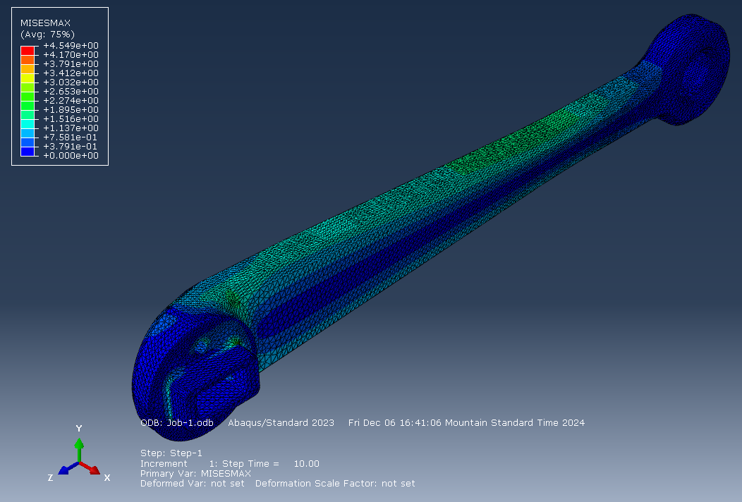

Figure 5: Stress concentration analysis of robot weight on leg segment.

From the FEA analysis, as shown in Figure 5, we expect the stress to be concentrated around the bends with a maximum stress estimated by the model to be 4.55 MPa. From [1], we gather that the yield strength of our leg is 26.082 MPa. Our prototype will have a design factor of safety of 5.7, which is more than enough to withstand testing for motor stall torque. This theoretically means that there is some room before yielding, allowing room for possible 3-leg analysis in the future.

**Appendix C: Actuator Design**

Figure 6 shows the actuator design. The motors are geared through the belts to a ratio of 10:1 at the joint. The motors have incremental encoders with 5000 counts per rotation attached to their shafts. The left image shows the top portion of the actuator, which links the central gear to the bottom gear. A diagram can be seen in Figure 7.

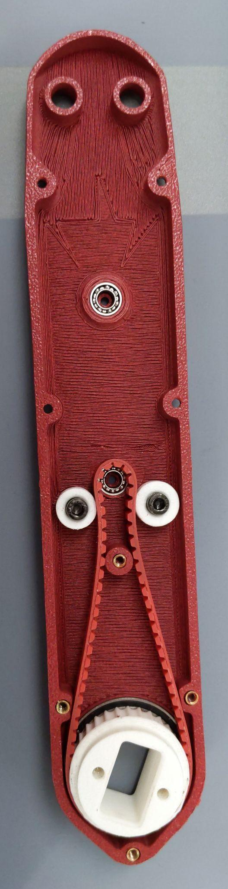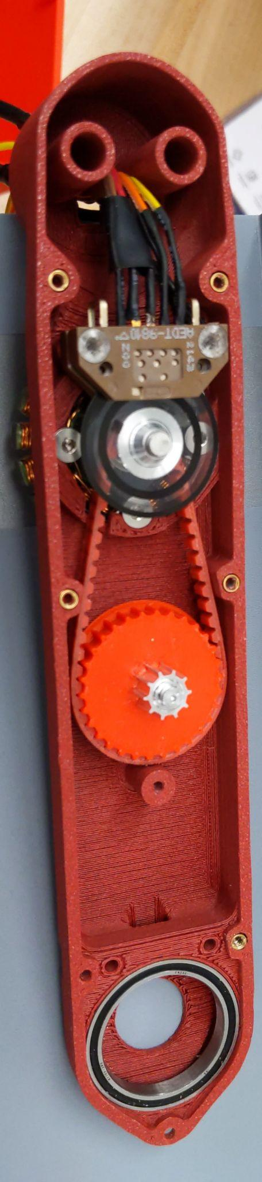

Figure 6: Open actuator module.

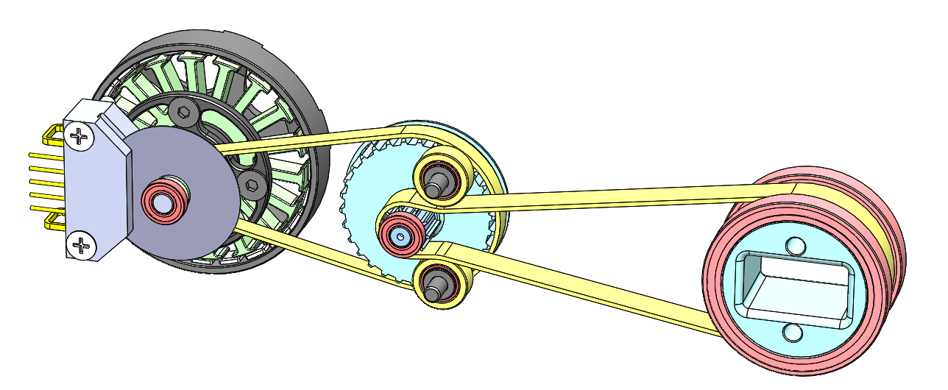

Figure 7: Actuator module diagram.